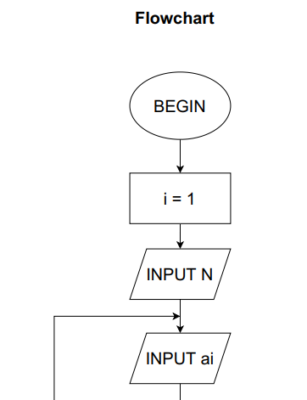BEGIN

INPUT N

i = 1

WHILE ( i <= N)

DO

INPUT ai

i = i + 1

END DO

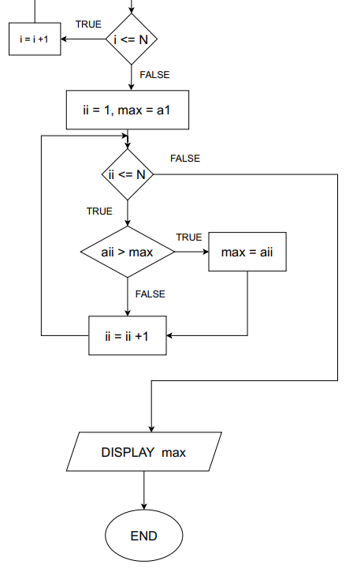 a1 = max

ii = 1

WHILE (ii <= N)

DO

IF (max < aii)

max = aii

END IF

ii = ii + 1

END DO

DISPLAY max

END